Waverly vipers 11
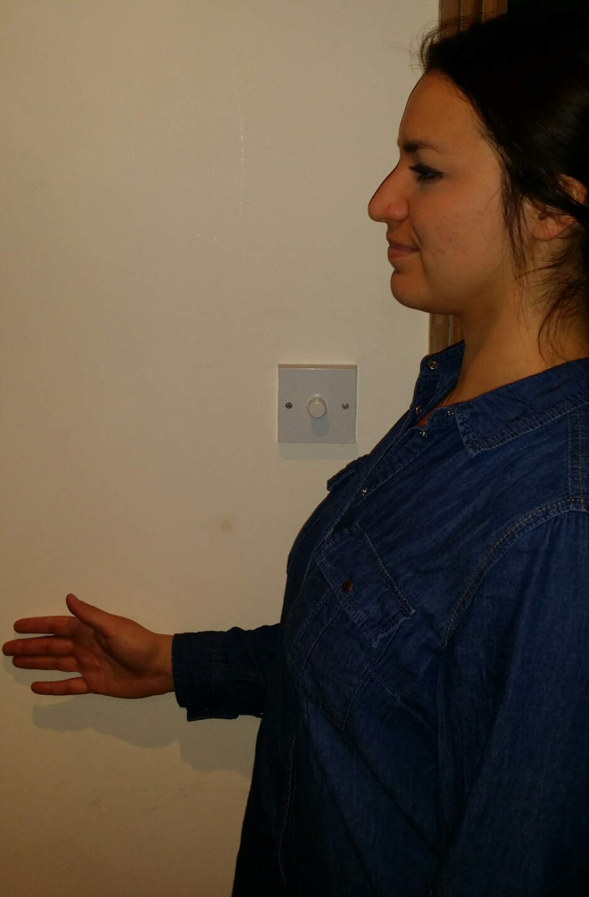
Rotator cuff
Stand sideways along a wall with your elbow at a 90-degree angle. Place the outside of your forearm against the wall.Press into the wall, contracting your muscles for 5 seconds, but don't move your shoulder. Repeat five times.Turn around and place the inside of your forearm against the wall and repeat with other forearm.

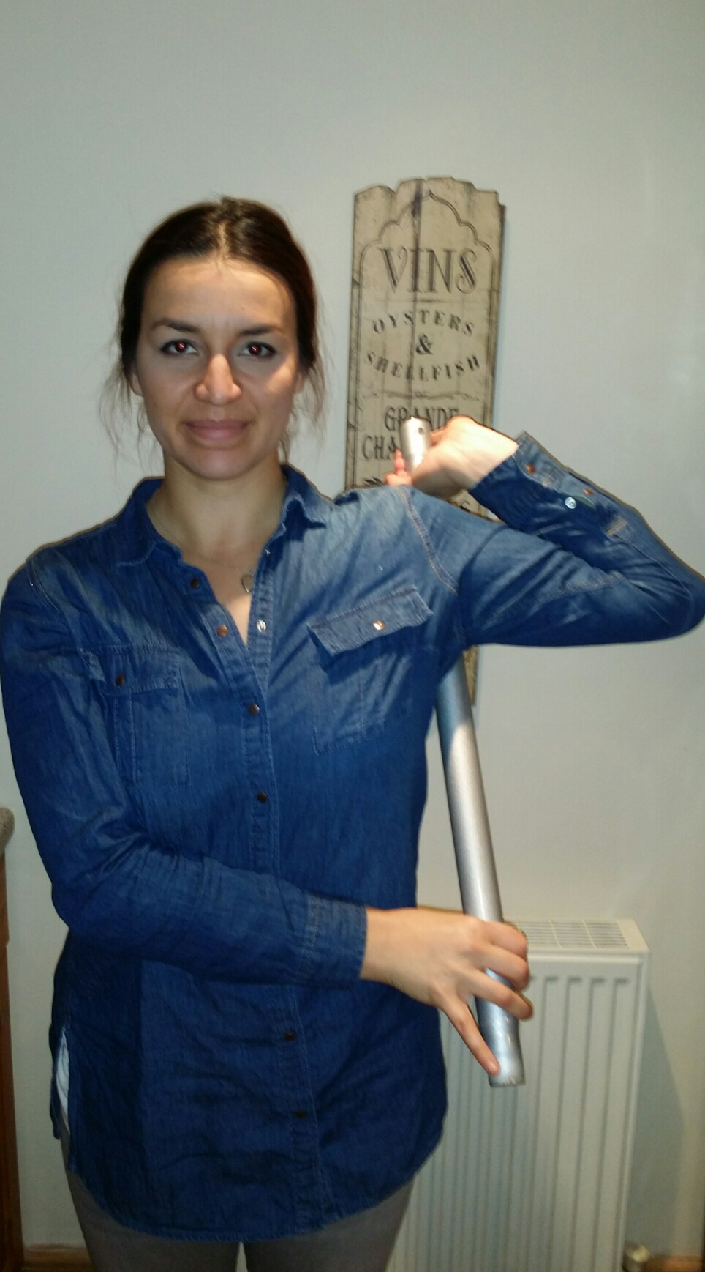
Subscapularis strech
Grasp end of pole to side of head with other end of pole behind arm. Bring elbow forward slightly and bend wrist back. Reach around body with opposite arm and grasp lower end of pole. Place pole in middle of back side of upper arm. Position elbow at height of shoulder. Pull lower end of pole forward so shoulder is externally rotated. Hold stretch for 30 sec. Repeat with opposite arm.

