Waverly vipers 21
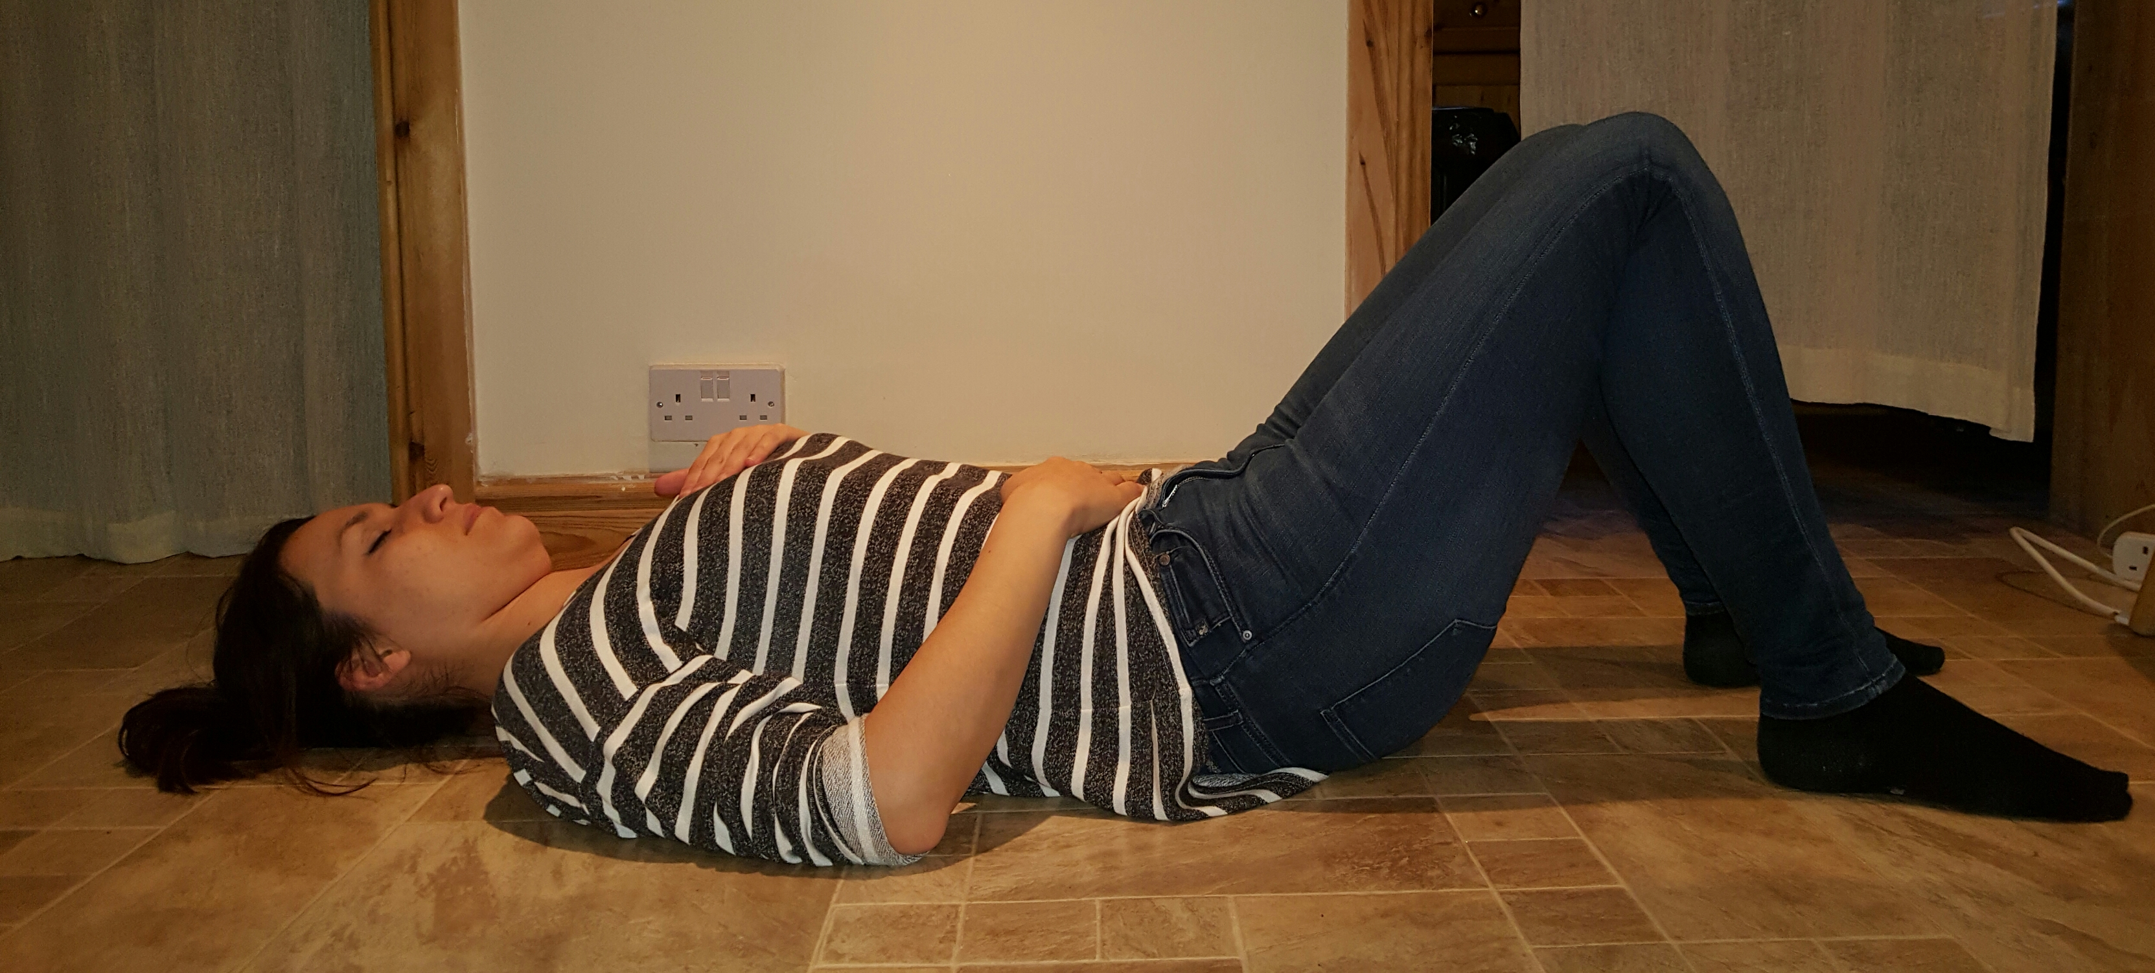
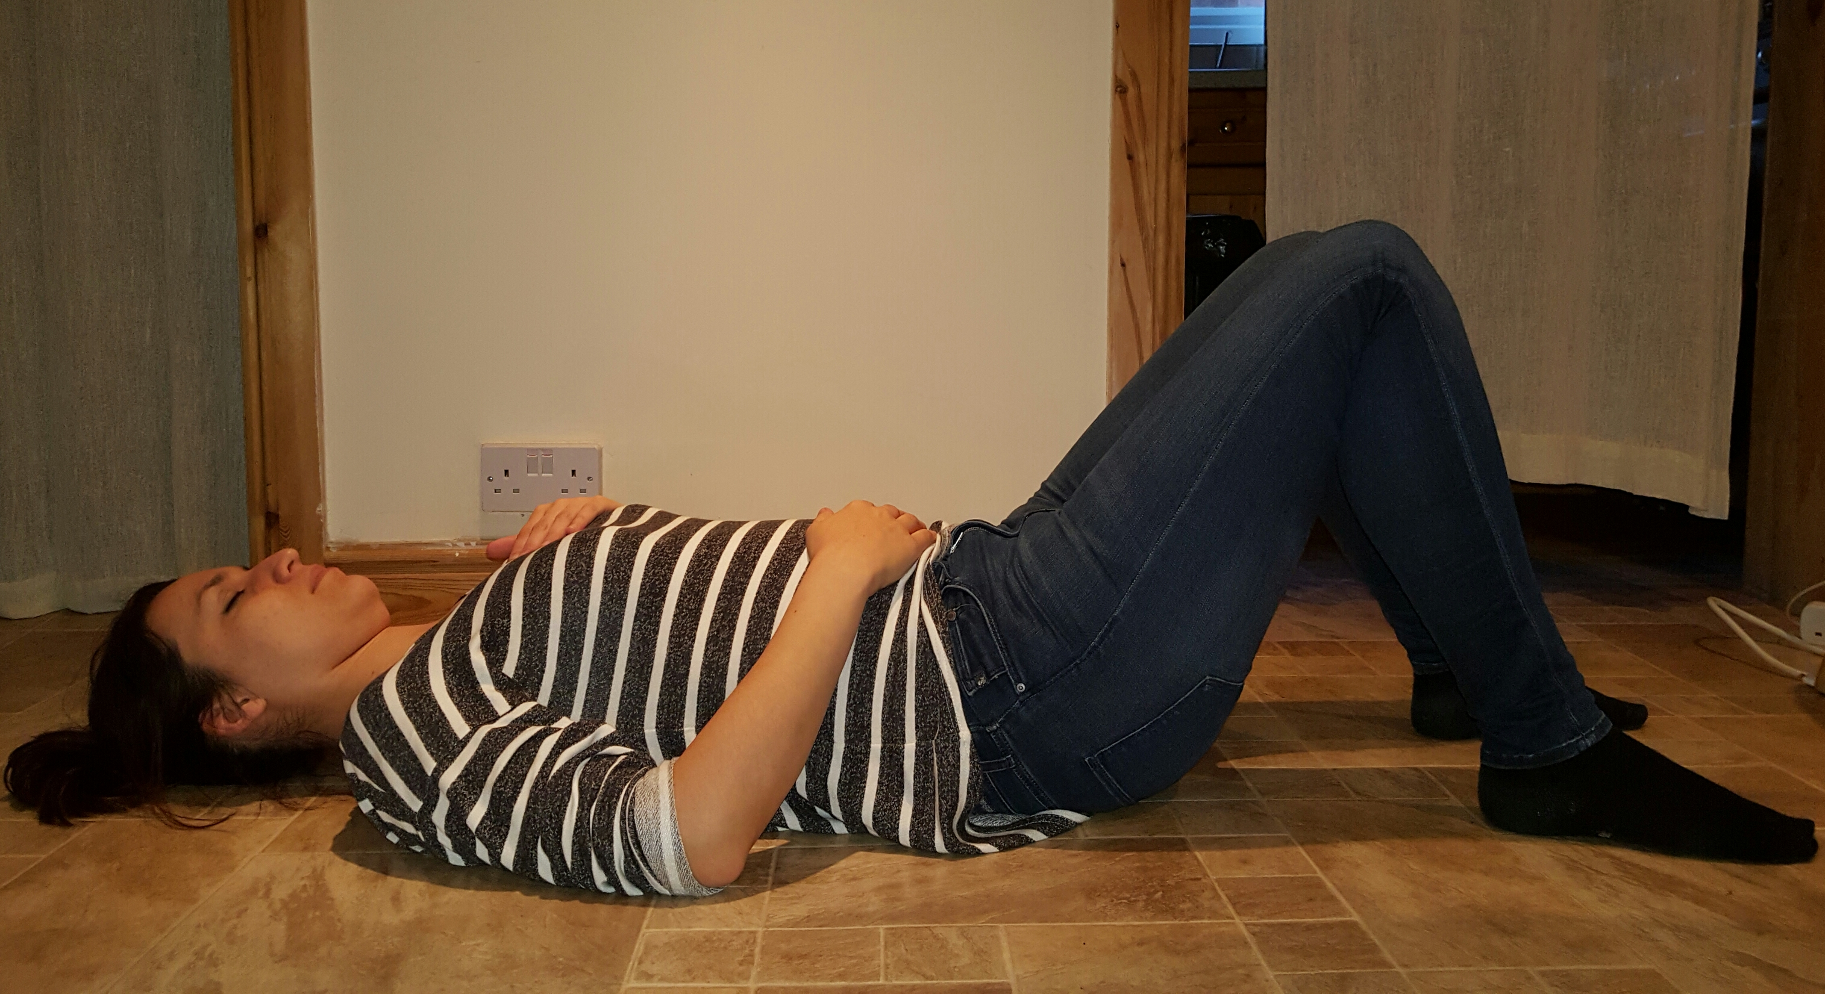
Diaphragm breathing. Lying on your back with your knees bent, place your palms at the bottom of your rib cage. Take a breath in through your nose, allowing your diaphragm to expand your stomach, keeping your chest as still as you can. Feel your stomach rise beneath your hands. Exhale through your mouth and repeat. Do this exercise while sitting up when the lying exercise becomes easy.
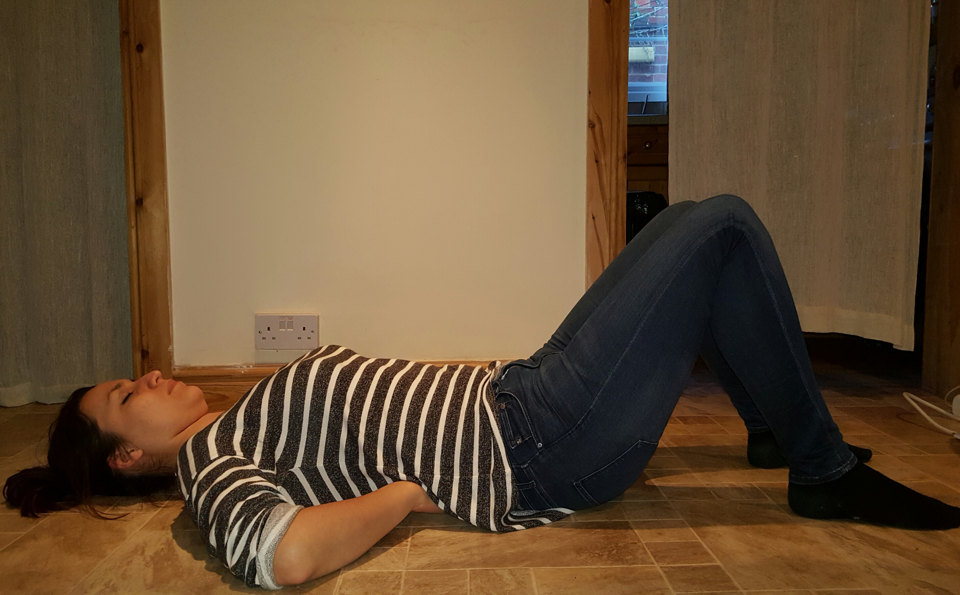

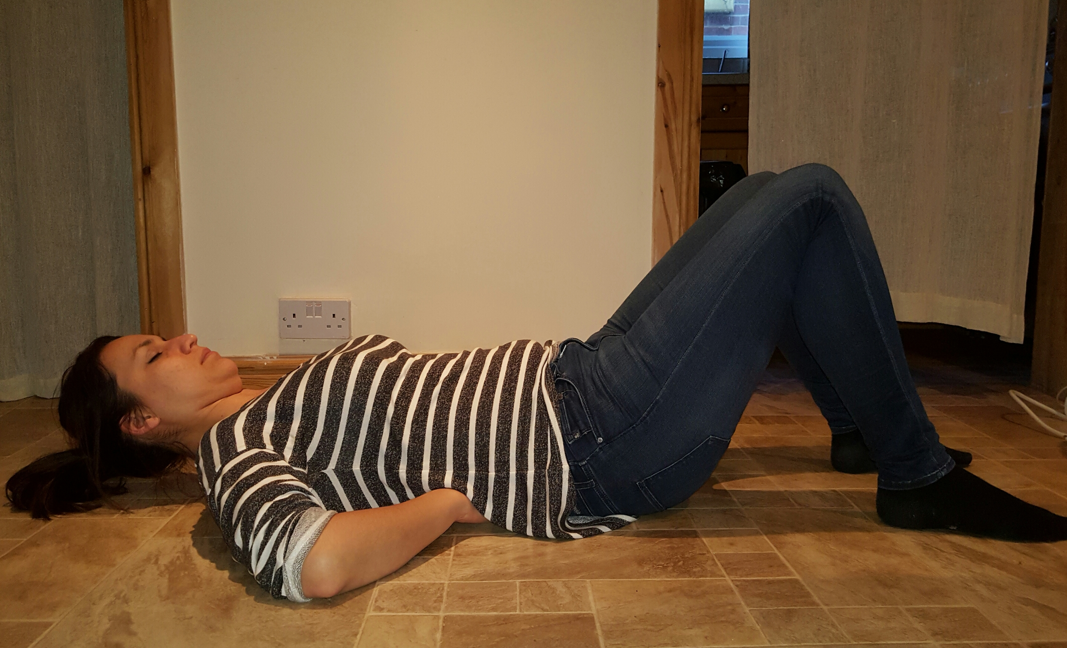
Curl up. Lie on your back on the floor. Bend legs. Place your palms underneath the natural arch of your lower back to preserve the curve. Depending on the size of your arch you can put one hand on top of the other or simply clasp your hands together. Slowly raise your chest, shoulders and head as a one unit off the floor without bending your lower back. Imagine that your abdominal muscles are shortening and they are pulling your shoulders off the floor. The range of motion is short – you don’t have to come too far off the floor. Keep the position for couple of seconds while breathing deeply. Then slowly return to the starting position. Switch your legs on each set your do. Sets 10×3

